**Week-08-Sorting Algorithms-Bubble and Selection**

**Week 08-01-practice session coding**

**Reg no : 241001159**

**Name : padmavathy.M**

**Q1)**

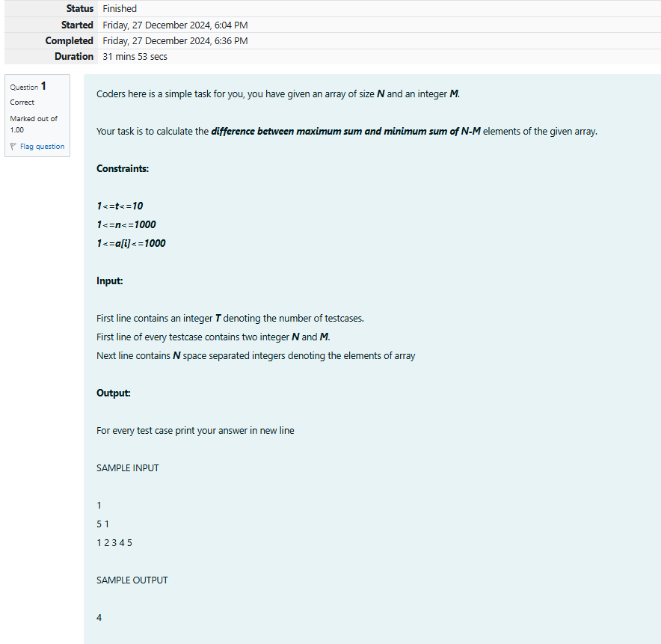

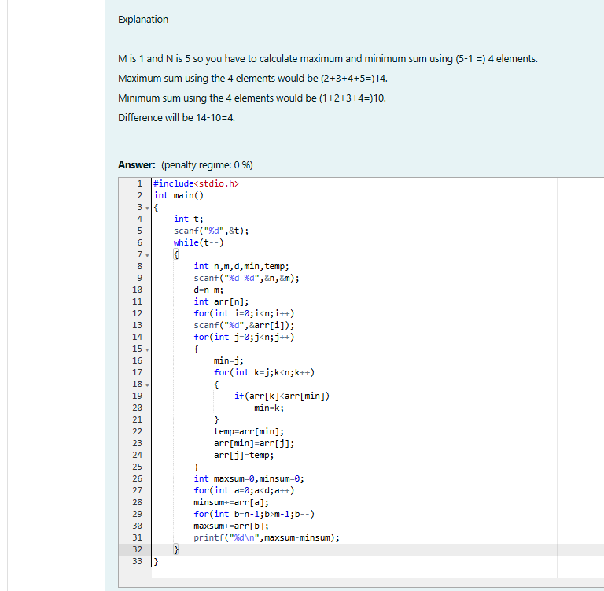

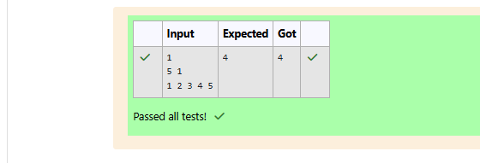

**Week 08-01-practice session coding**

**Reg no : 241001159**

**Name : PADMAVATHY**

**Q2)**

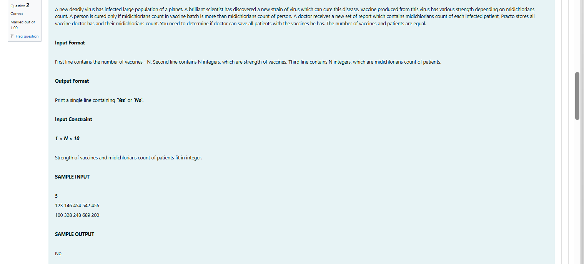

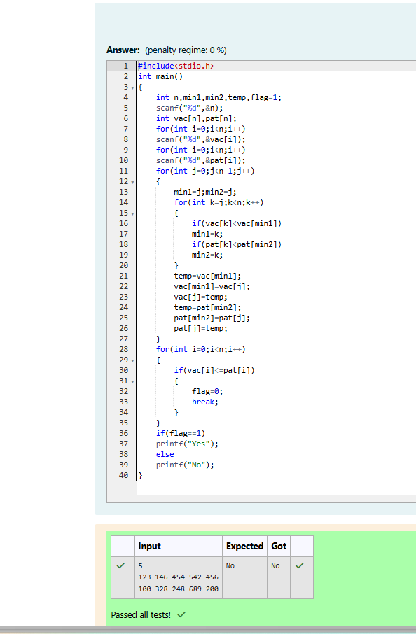

**Week 08-01-practice session coding**

**Reg no : 241001159**

**Name : padmavathY.m**

**Q3)**

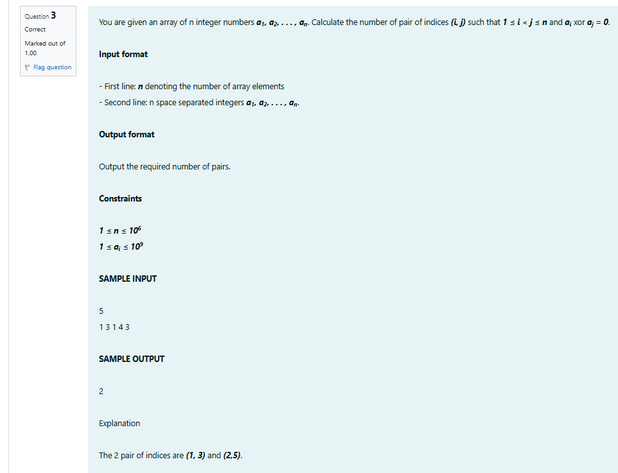

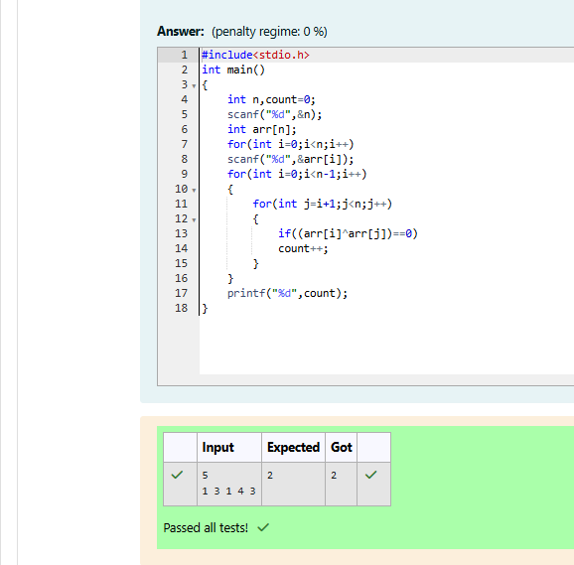

**Week 08-01-practice session coding**

**Reg no : 241001159**

**Name : padmavathy.m**

**Q4)**



